Potential data inconsistency: Seattle versus King County?
@Zoe : why numbers are larger?

Issue with fitting HIV testing data by MSM in Stage2: we separated the likelihood and increase the weight
- Need to revise the internal mechanism for high risk MSM

King County Data (Menza 2026):
https://academic.oup.com/cid/advance-article/doi/10.1093/cid/ciag209/8541760
- The PHSKC SHC was a site of the DOXYPEP trial [2]. When trial enrollment was halted in May 2022, we offered all current trial participants doxy-PEP as part of the open-label extension phase >> Doxy PEP uptake starting in May 2022
- By March 2023, we began offering doxy-PEP prescriptions to patients who did not participate in the trial and tracking doxy-PEP use. >> scale up
- From May 2023 to June 2024, the proportion of MSM and transgender and nonbinary (TNB) people attending the Public Health—Seattle & King County (PHSKC) Sexual Health Clinic (SHC) who reported doxy-PEP use in the prior month increased from 12% to 45%
- In community surveys conducted at summer Pride events in 2023 and 2024 [9], self-reported doxy-PEP use in the prior month increased from 15% to 31% among MSM and from 18% to 33% among TWSM [10].

Aug 2020 | 0 | DoxyPEP Trial began
May 2022 |  | Continuing the coverage for trials participants
May 2023 | 12% - 15% (last month)
June 2024 | 30 - 45% (last month)

We used King County, WA, syphilis surveillance data from January 2017 to June 2025 to assess the changes in monthly syphilis diagnoses (all stages) associated with the implementation of doxy-PEP.

Key results
Syphilis cases declined dramatically following the implementation of doxy-PEP in King County, WA. Compared to a counterfactual scenario without doxy-PEP implementation, there were 52.3% fewer syphilis cases. The relative difference in syphilis cases was greatest among cisgender men (53.1% fewer cases) but also affected cisgender women (46.9% fewer cases) and TNB people (33.1% fewer cases).
Despite these large differences in cases relative to doxy-PEP implementation, the number of pregnant women with syphilis and the number of cases of CS in King County continued to rise.

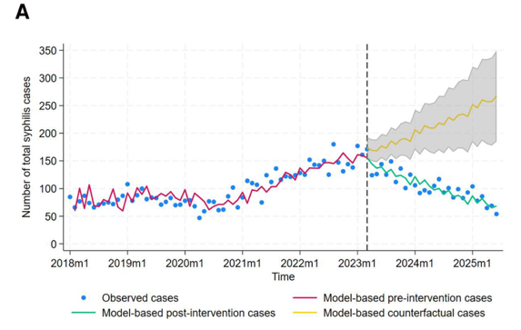

Report a total cases in Seattle decreased between 2022 and 2023, but the cases in King County continue to climb.

Since 2023, they are observing consistent decline in reported cases in each month

By sex: 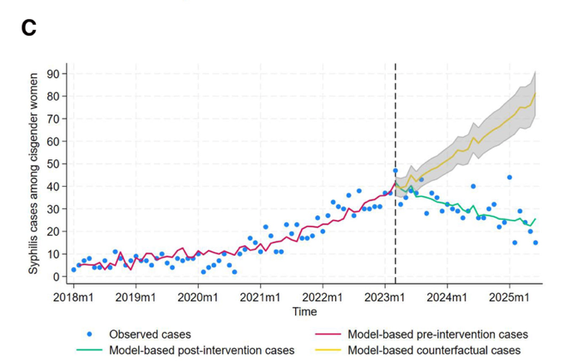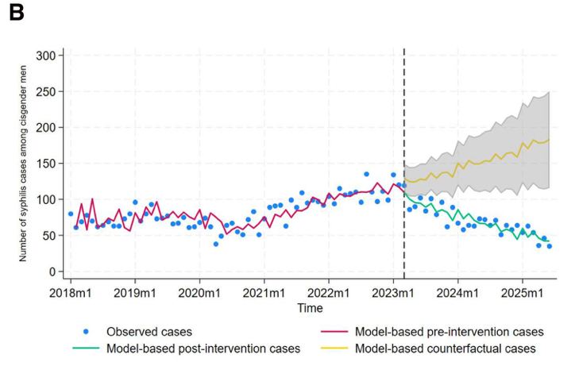

Again, the biggest difference is that although we project a decline in both group that is not too far from the data our future rate continues to climb two year 2025, and after that by their reported cases continued to decline

Potential Mechanisms driving the differences:
- Underlying observed cases? Inconsistencies in Seattle?

- MSM proportion of male diagnosis:
“Across the study period, MSM comprised 69% of all syphilis cases among men (84% in 2017–2020 and 56% in 2021–2025).”

SHIELD:
2017 : 82% -> 2020: 69%
2021: 64% -> 2025: 44%

Close proximity, they are both projecting a reduction in share of MSM among male diagnosis

- overlap between MSM and heterosexual network?

NHBS data on prop of msm partnership with females:
 | #have female partner | Total MSM | %msm with female partner
2008 | 1067 | 1109 | 0.14
2011 | 943 | 8012 | 0.12
2013 | 1065 | 9640 | 0.11
2017 | 1186 | 10104 | 0.12
2021 | 276 | 2241 | 0.12
2023 | 788 | 6007 | 0.09
 |  | Average | 0.12
Our model sets this to 12% as well.
3 reports include selected locations – the range of data is wide (2%-40%)

Other data (cited in seattle paper):
- weighted mean prevalence of bisexual behavior across multiple studies reviewed= 0.33 (0.23-0.45) >>> new drived estimate= 0.23 [0.1, 0.48]
- https://pmc.ncbi.nlm.nih.gov/articles/PMC3907399/

- Het women with HIV who have molecular link to MSM = 29%
- (Of heterosexual women for whom we identified potential transmission partners, 29% were linked to MSM, 21% to heterosexual men, and 12% to persons who inject drugs.)
- (among MSM only 4% were linked to heterosexual women)
- our data suggest that HIV infections among heterosexual women predominantly originate from MSM, followed by heterosexual men. Although few MSM were linked to women, suggesting that a minority of MSM are involved in transmission with heterosexual women, these transmissions represent a substantial proportion of HIV acquisitions by heterosexual women.
- https://pubmed.ncbi.nlm.nih.gov/26302431/

- Underlying reductions in transmission (not related to doxy-pep)?
The number of primary and secondary syphilis cases among both men and women in the United States declined from 2022 to 2024, and it may be that at least part of trend we observed is unrelated to doxy-PEP.

- Misalignment of the STI testing rates driving transmission up or down?

